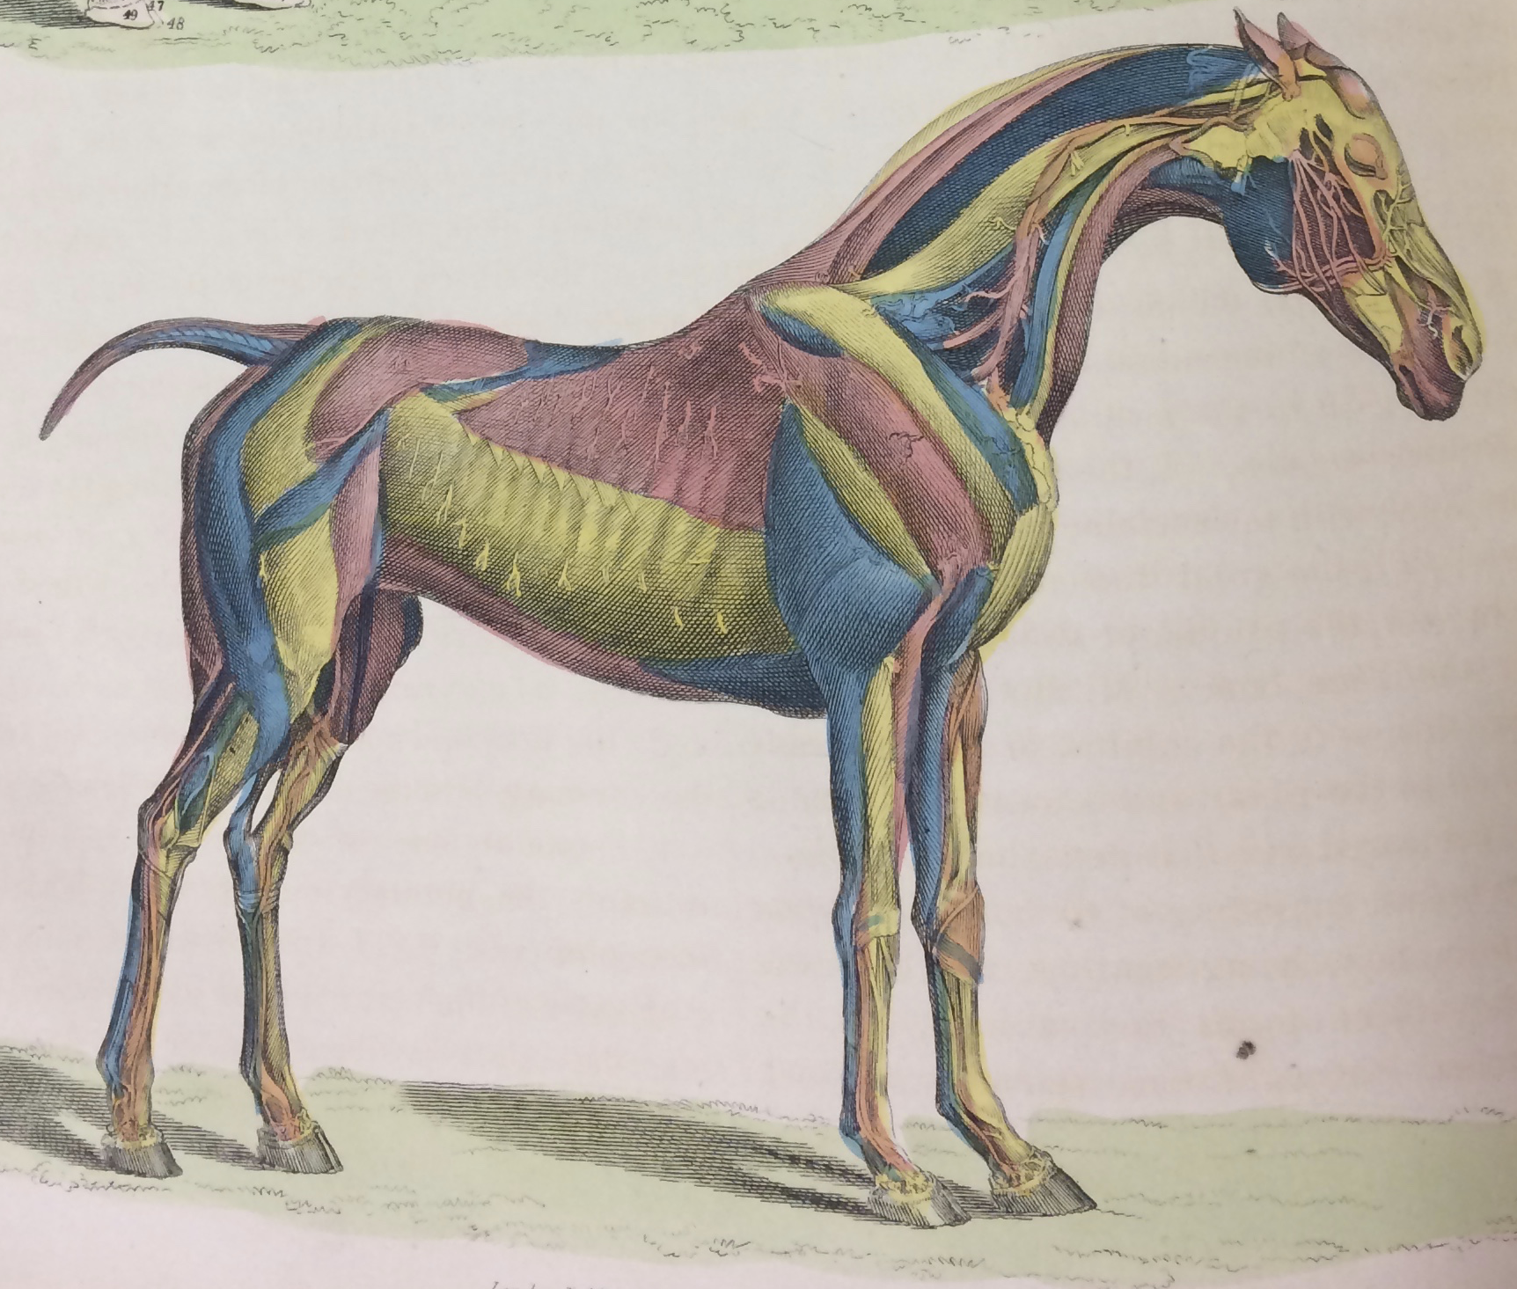

# Open to the public! To register visit:

# https://equinehistory.wordpress.com/conference/

Embodied Equines

November 13-15, 2019

9:00 AM – 5:00 PM

Wed. November 13, 3:30 – 5:00 pm, “The Equine Experiment” Dr. Sandra Swart

Fri. November 15, 11:45 - 12:45 pm, Tour of the W.K. Kellogg Arabian Horse Library

Sat. November 16, 10:00 - 12:00, Exhibit of the Lasker Collection at the Huntington Library

## University Library, CAl Poly Pomona

# The Equine History Collective and the W.K. Kellogg Arabian Horse Library present the 2nd annual Equine History Conference:

✹

✹