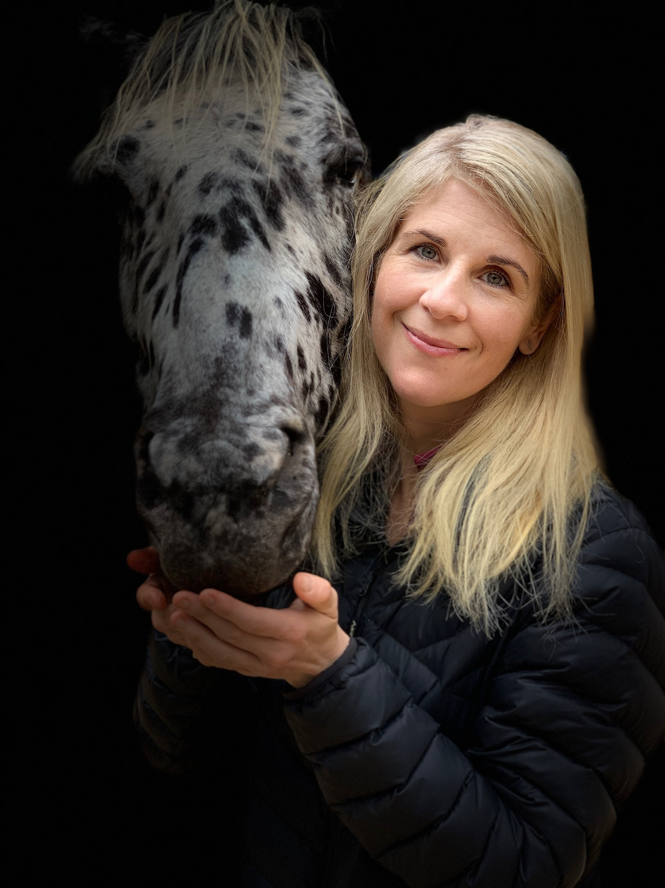

**Embodied Equines: The Equine History Conference 2019**

SANDRA SWART is a free-ranging primate and the Professor of History at Stellenbosch University. She researches the social and environmental history of southern Africa, with a particular focus on the shifting relationship between humans and animals. She has authored and co-authored over 60 peer-reviewed articles and chapters, and, on horses, has co-authored with Greg Bankoff, Breeds of Empire The Invention of the Horse in Southeast Asia and Southern Africa 1500-1950 (Nias Studies in Asian Topics, 2007) and is the sole author of Riding High – Horses, Humans and History in South Africa (Witwatersrand University Press, 2010).

The Equine Experiment

## Open to the public! To register visit:

## <https://equinehistory.wordpress.com/conference/>

### November 13, 3:30-5:00 pm

### University Library, Cal Poly Pomona

# Dr. Sandra Swart